**Calligraphy**

**The art of beautiful writing**

|  |  |  |
| --- | --- | --- |
| Supervisor : | Sir Nirten | |
| Batch : | 2212D. | |
| Group : | **Calligraphy**  **The art of beautiful writing** | |
| Serial No. | Enrollment No. | Student Name. |
| 1. | 1436406 | MARYAM |
| 2. | 1386749 | MOHSIN |
| 3. | 1439929 | ZUBAIR |
| 4. |  | MURTAZA |

**Acknowledgement**

*The first, we would like to express my special thanks of gratitude to my teacher SIR NIRTEN who helped a lot in finalizing this project within the limited time frame, valuable counseling and assistance for the accomplishment of this project.*

*Secondly, we would also like to thanks the e-project team at Aptech Head Office, who provided us the opportunity to do this interesting and informative project about calligraphy the art of beautiful writing.*

*Thirdly, we also thank the e-project team for giving this task to us. Following are the benefits of this Project:*

* *Re-enforcement of skills happens in the experimental learning process.*
* *A mentor, ensuring that we do not get drifted, constantly guide us.*
* *It gives us a lot of confidence to face an interview as we have worked on a project. We can explain virtually everything on the subject we have learnt.*

**Synopsis**

Calligraphy the art of beautiful writing is a very essential feature in art There are so many aspects of creating art that are fun an enjoyable – the practice, experimentation, and work to make each piece – that hours pass as if they were minutes. Sharing and engaging with the amazing writing community to help other create their own masterpieces is also incredibly rewarding. Calligraphy has become very popular recently – examples of it can be seen in many advertising areas, restaurant menus, posters and even party invitations.

* Feedback section is provided to the user. The website includes filter in which user can choose any type of calligraphy and the website will schedule the user with that particular type of calligraphy

user can browser the type and select fonts of interest. The user will get the info about selected type.

. The synopsis of calligraphy the art of beautiful writing is to develop a general purpose about providing information where any type (such as Indic, Arabic, and Greek etc.) the user can get more information by doing the type browser it will help user to get more about that particular type

Anyone can be the user of the system. When the user type in the URL of the website, a home page shown.

The user will go to the gallery, About, Contact us, design page from the home page.

*Problems Definition*

*Mr. “A” is the owner of the huge academy of art and calligraphy. He is famous for the talent and passion of the art he provide to children. As the number of Children is increasing day by day, the teachers of the art and calligraphy keeps on increasing. To popularize it more the owner of the academy has*

*Decided put step towards making the website of his academy. For this he has*

*Approached you to make the website. He also wants to distribute his*

*Art work to the registered children’s by charging the appropriate fees.*

*Those children’s who had registered in the web site are able to see*

*The entire art work they are showing in website. For unregistered user the page will have following*

*Link access but the method of the art work will not be activated. He has*

*Also written various art books for the calligraphy and its types and*

*Now he wishes to sell this book online through his website.*

*He also wants the user to provide some new fonts*

*Functional Requirement Specification (fRS)*

*To popularize his art and calligraphy, Mr. “A” has listed out the few*

*Points which he wants to be there in website.*

*Here are list to be design in the project*

*Top of the website should have Title in Calligraphic and should provide brief information about calligraphy.*

*There should be a well-designed menu with all sections listed.*

*Various sections such as Traditional Calligraphy, Contemporary Calligraphy, Hand-lettering & Design, and Modern Calligraphy etc. should be provided.*

*Section explaining various forms and styles should be provided.*

*Filter on designs as Arabic, Indic, Greek etc should be provided.*

*Proper description of the letters and fonts must be added in the website*

*Gallery should be added for viewing different Calligraphic styles.*

*Feedback must be allowed to enter by the viewer*

*Site map, Gallery, about us, Queries link, Contact us link must be added.*

*About Us and Contact Us: This menu option should display Email id, address, and contact number of the organization4.*

*Color combination must be uniform throughout the project.*

*Navigation must be smooth.*

*Scope Of The Work (Briefly)*

*The name of the project is calligraphy the art off beautiful writing the website provides the user various facilities .in this project we can easily maintain the art and calligraphy details.*

*It’s gives complete information of calligraphy the art of beautiful writing it’s types, fonts, and letters etc. we can see the calligraphy details by searching the particular*

*Calligraphy the art of beautiful writing automation system provides ability to view any type of different category available in the academy. Admin can leave feedback by entering name and email .Users allotted to him and can view the feedback submitted by Users. That means which has the system which provides the facility to the user of the website to purchase the book from the academy without any difficulty and complexity.*

***English Sitemap***

Gallery

Contact us

Home page

design

About us

***Wireframes***

***Top Layout***

***Home gallery About Contact design***



***Gallery page***

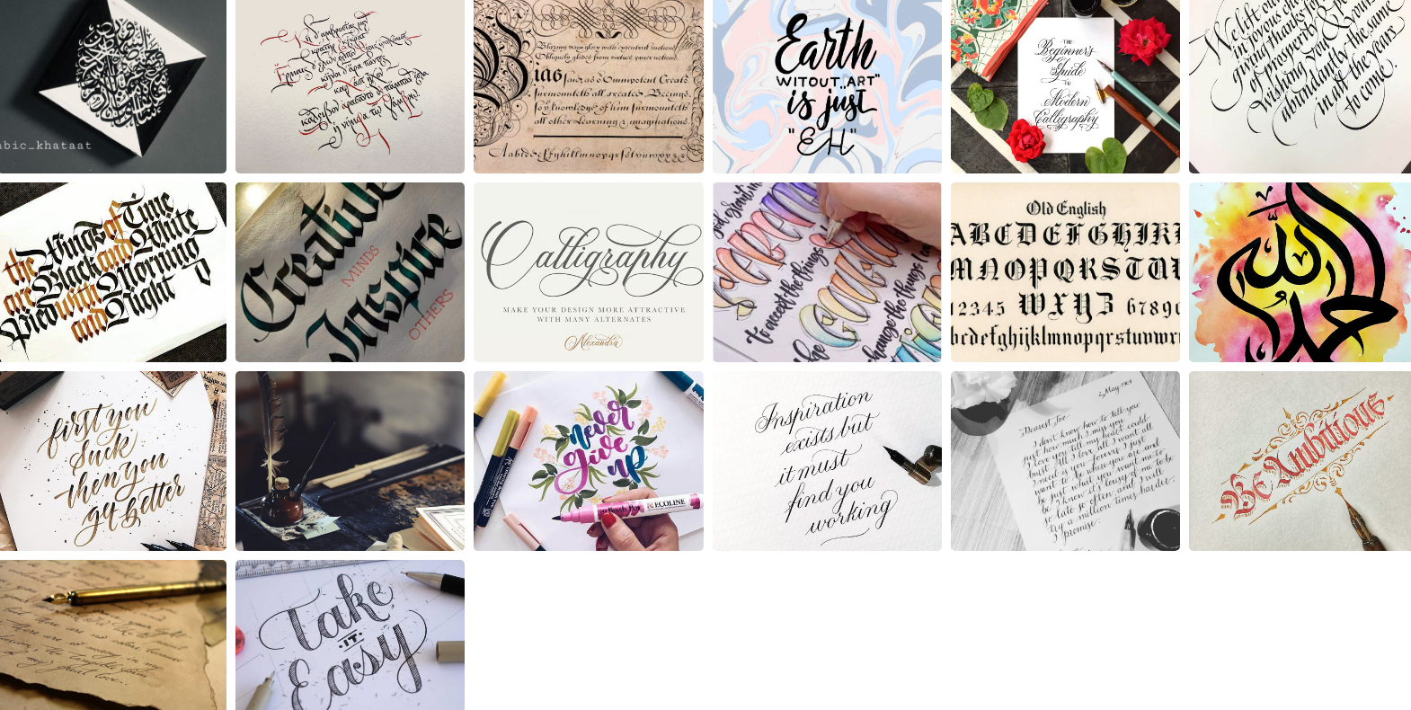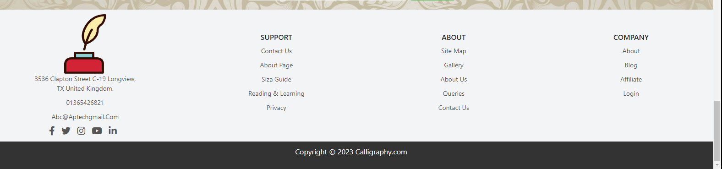

***Bottom Layout***

***Home page***

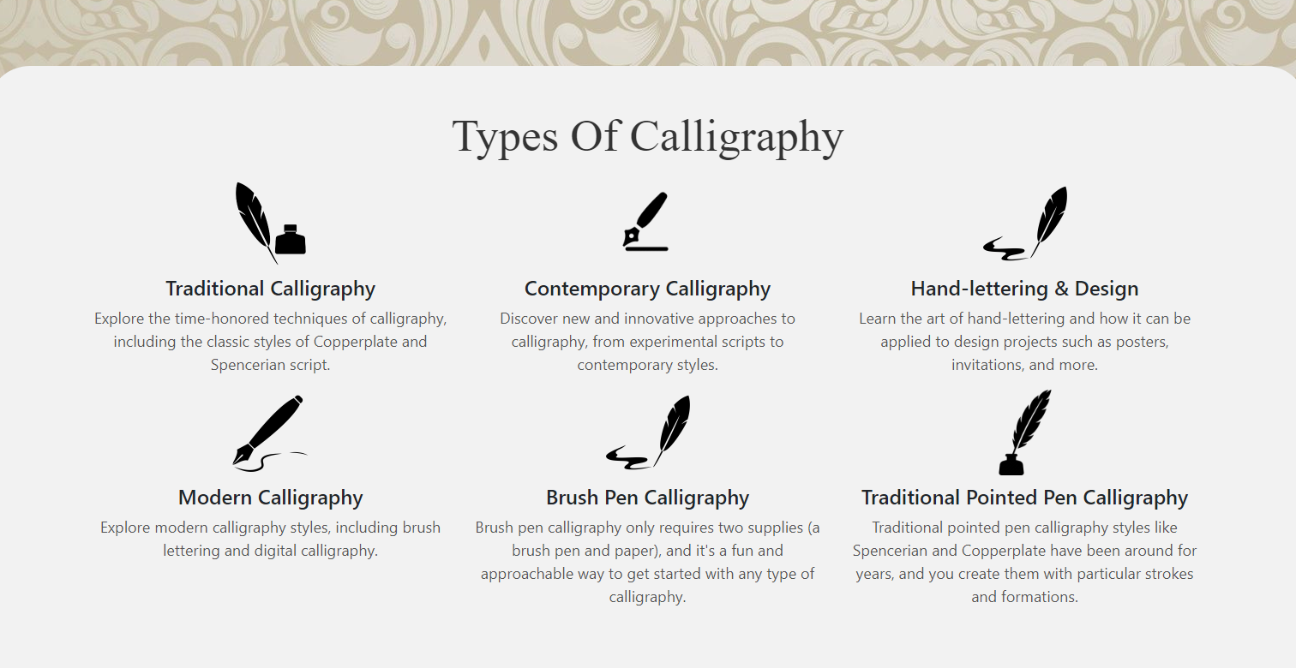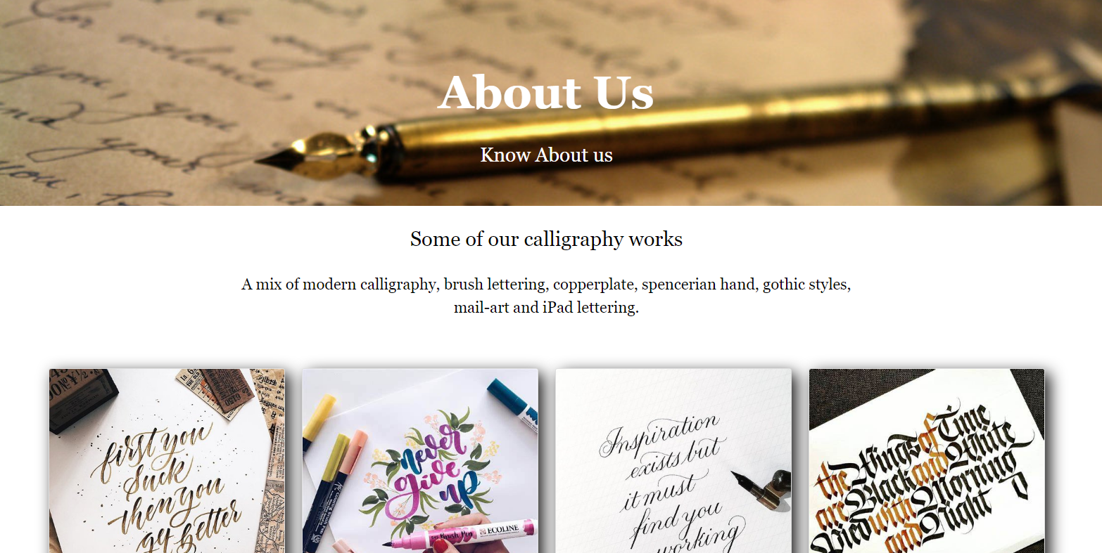

***About Page***

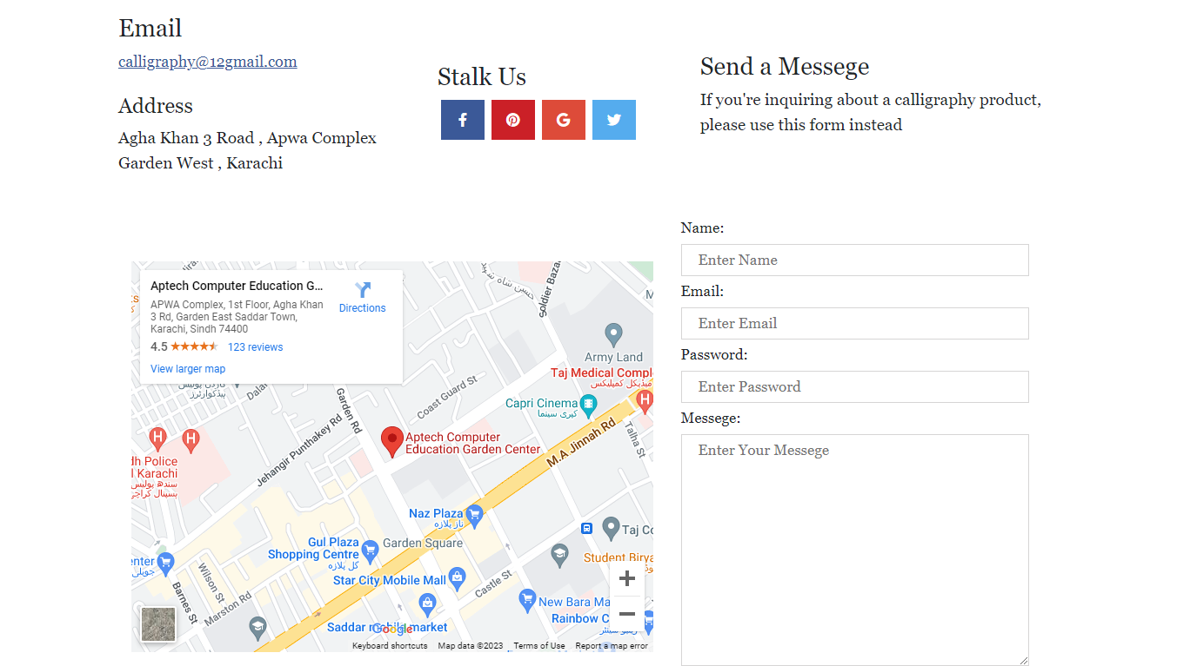

***Contact us page***

* User can get in touch through contact us page

***Design page***

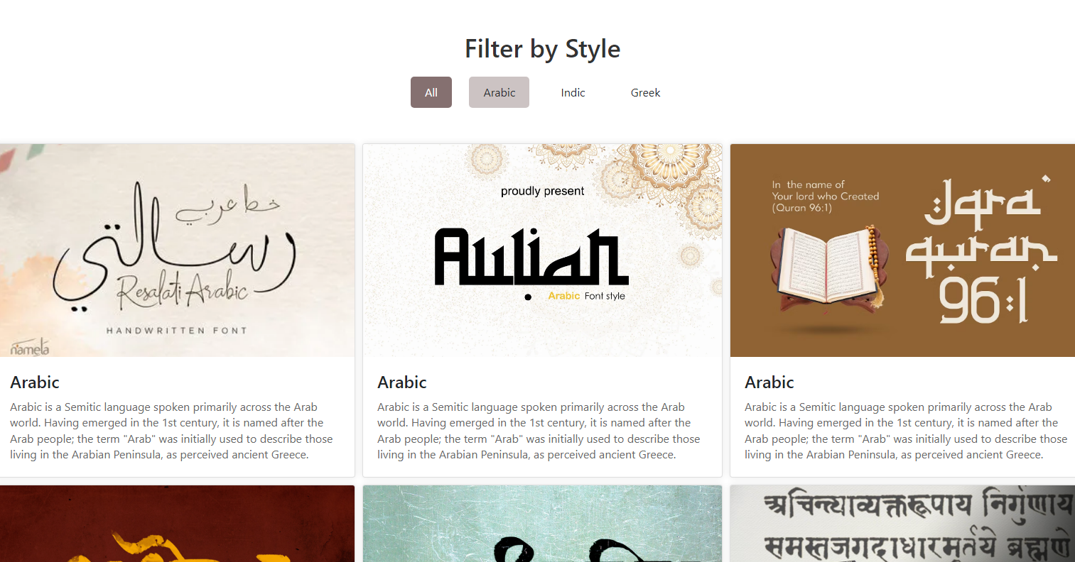

* ***Design page includes filter by using it user can get information about the particular selected type of calligraphy such as (Arabic, Indic, Greek)***

***Indic calligraphy***

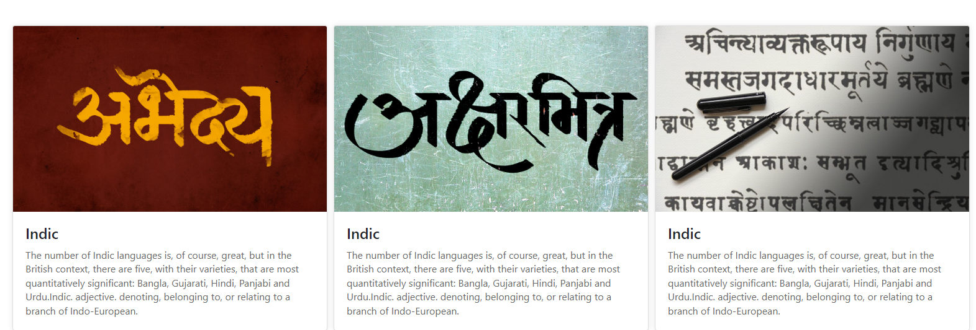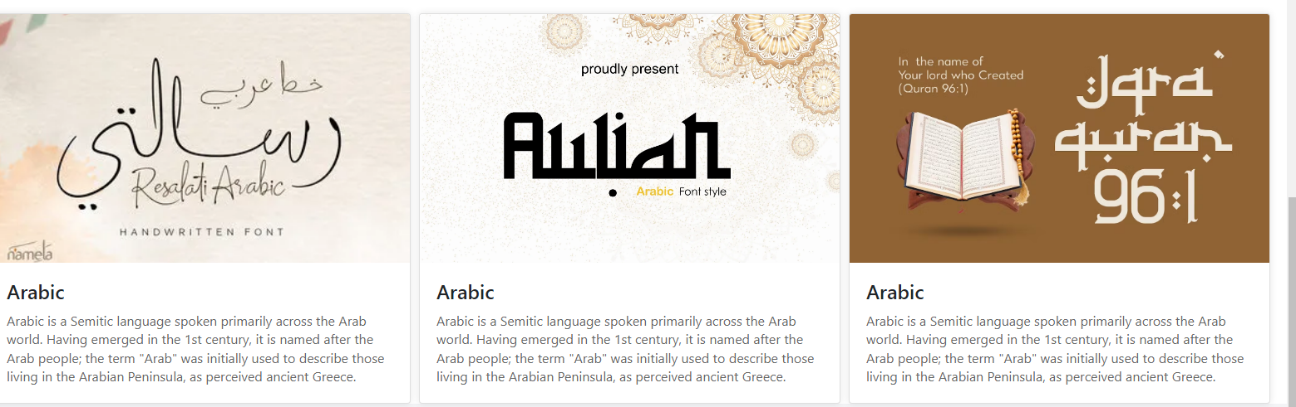

***Arabic calligraphy***

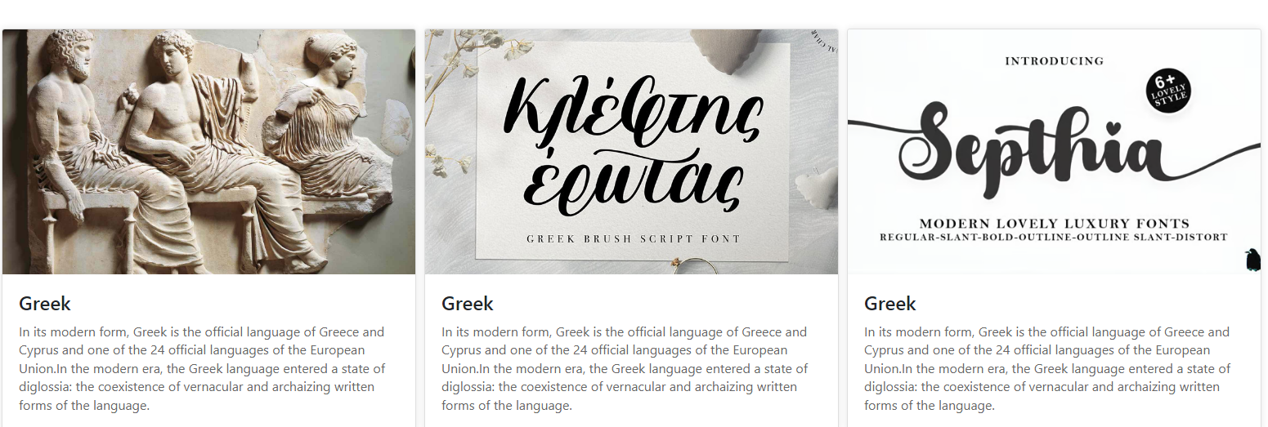

***Greek calligraphy***

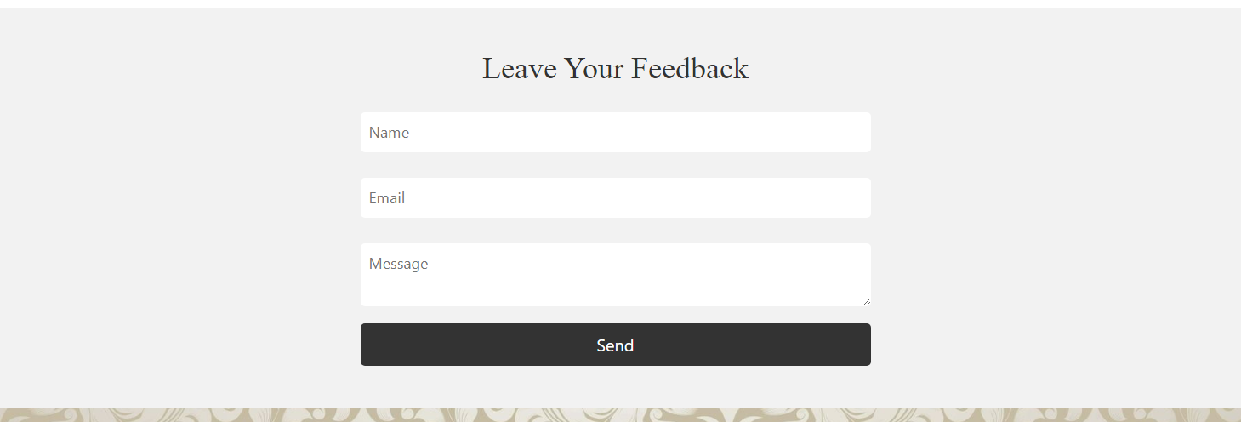

* User can leave their respective comments in feedback section in home page ***Task Sheet***

|  |  |  |  |  |  |  |
| --- | --- | --- | --- | --- | --- | --- |
| Project Ref.No:  Ep/Advertisement  Portal Management  System /01 | | ProjectTitle | Date Of preparation Of Activity Plan | | | |
| No. | ***Task*** | **C**  **A**  **L**  **L**  **I**  **G**  **R**  **A**  **P**  **H**  **Y**  **The**  **Art**  **O**  **F**  **Beautiful**  **Writing** | ***Actual***  ***Start Date*** | ***Actual Days*** | ***Team-Mate***  ***Name*** | ***Status*** |
| 01. | ***Home page*** | 07  -  A  P  R  I  L  -  2  0  2  3 | 3  0  -  D  A  Y  S  - | Zubair |  |
| 02. | ***Gallery page*** | zubair |  |
| 03. | ***About page*** | Maryam |  |
| 04. | ***Contact page*** | Maryam |  |

|  |  |  |  |  |  |  |
| --- | --- | --- | --- | --- | --- | --- |
| 05. | ***Design page*** |  |  |  | Zubair |  |
| 06. | ***Documentation*** | Maryam  +  Mohsin |  |

We are really grateful to you for reading our documentation …☺